**Computer Engineering**

**Project Report**

Levels: 3th year engineering cycle

Major: IT and network engineer

**EMSI Digital Library**

**Under the theme:**

Année Universitaire : 2022/2023

Made by: -IBRAHIM MAFHOUM

-LITNITI MOUNSEF

-YOUNESS AZMI

-OUALID AMSAGUIN

Supervised by : -Mme Hassna BENSSAG

# **Acknowledgment**

**SEPECIAL THANKS**

**Before going any further, we would like to thank all the stakeholders in this brief. We would like to thank all the people who have contributed in any way to this project and the success of this project.**

**We would like to thank once again Mme Hassna BENSSAG , for his benevolence, his supervision and the trust he has given us by supervising us for the achievement of this project.**

**I would like to thank (mounsef litniti) an old teacher of mine Mr. ZRIWIL for his efforts all over 6 years and for all the knowledge he gave us and pathing my way in engineering from the first moment I walked in his classes.**

**We thank our dear parents, who have always been there for us and have played a fundamental role in our education and have supported us, whether morally or economically during our studies. Our brothers and sisters for their support.**

**We would like to thank all the professors, lecturers and the administrative staff of EMSI for their dedication and help.**

**Finally, I would like to thank me for all my efforts.**



# **Table of Contents**

1. Project Presentation 4

a. General Introduction 4

b. Project Introduction 5

c. Identification du projet 6

d. Problematic 7

e. Objective 8

f. Scope 9

g. Features 10

h. Advantages 11

i. Manager Aspect 12

2. Tools used in conception and realization 13

a. Introduction to tools 13

b. UML 13

c. html 14

d. css 15

e. SAP Power Designer 16

f. StarUML 17

g. canva 17

3. Conception 18

a. Use case diagram 18

b. Class diagram 18

c. Sequence diagram 19

1) login 19

2) add 20

4) delete 28

5) logout 32

8) exit 38

9) menus 39

4. Realization 44

a. App Preview 44

b. Annex du code 50

5. Conclusion 50

# Project Presentation

## General Introduction

An information system is a complex object that evolves in an even more complex environment.

Information systems had a remarkable evolution thanks to computer science, which has progressed in the field of information and communication technologies.

The latter offer the possibility of accessing even larger masses of data on various media and supporting different modes of interaction.

Over the years, companies have been progressing rapidly in order to meet the needs of their customers, who are becoming more demanding in terms of cost, quality and time, without forgetting to take into consideration the competition with other companies.

In order to meet these criteria, companies rely on information systems that must use efficient and easy software development processes that rely on desktop applications.

Our main objective is to make a Emsi Library WebApp .

Our report allows you to have a general idea of my project, of the working tools used as well as the fruit of our work.



## Project Introduction

Introducing EmsiLib, the digital library app designed for the EMSI school community. EmsiLib revolutionizes the way students and teachers interact with the school library by providing a user-friendly and comprehensive platform. With EmsiLib, students can effortlessly browse, search, and rent books from the extensive collection, all within a few taps. Even if a desired book is unavailable, students can easily place orders and receive notifications when it becomes accessible. The app also grants students access to a vast multimedia library, offering an extensive array of e-books, videos, and educational resources, including PDFs of teachers' courses. EmsiLib ensures a seamless borrowing experience by sending timely reminders to return books before the deadline. Additionally, students can engage in vibrant discussions through the comments section on each book's page, rate their reading experiences, and save books of interest to their personal wishlist. On the administration side, EmsiLib empowers staff to efficiently manage books, accept new orders, oversee the status of each book, and conveniently send notices to students. With its user-friendly interface, EmsiLib transforms the EMSI library into a dynamic digital space that promotes learning, exploration, and collaboration for the entire school community.

## Identification du projet

5 W’s or WWWWW (stands for who? what? where? when? why?) Is an acronym summarizing an empirical method of questioning. Its simplicity, logical and systematic character make it a descriptive framework for classical analysis.

-What?

Emsi Library WebApp

-Who?

LITNITI Mounsef and BASSIT Youssef

-Where?

EMSI

-When?

Starting: 15 Juin Ending: 22 Juin

-Why?

Make it easy to access school library from anywhere.



## Problematic

1. **Overview:**

The digitalization project aims to create a website and app for EMSI’s library to provide students with an easy and smart way to rent books and access a vast multimedia library of e-books, videos, and documents. The project also aims to provide the administration with an interface to manage books, multimedia, and orders of new books, as well as provide teachers with a platform to upload and manage PDF courses.

1. **User Interface:**

The website and app will have a user-friendly interface with easy navigation, a search bar, and clear instructions. The interface will be divided into two sections: one for students and one for administration. The students' section will have a dashboard to view their rented books and the status of their orders. They will also have access to the multimedia library, which will be organized by categories, and a Wishlist to save books. The administration section will have a dashboard to manage books, orders, and multimedia, as well as a section to view the status of rented books and send notices to students.

1. **Features:**

* Renting books: students can rent books from the library and receive notifications to return them before and after the deadline.
* Ordering books: students can order books that are not available in the library and receive notifications when they are ready to be picked up.
* Multimedia library: students can access a vast multimedia library of e-books, videos, and documents organized by categories.
* PDF courses: teachers can upload and manage PDF courses for students to access.
* Comments and ratings: students can leave comments and ratings on book pages to discuss and review them.
* Wishlist: students can save books they are interested in renting.
* Administration interface: the administration can manage books, orders, and multimedia and view the status of rented books.
* Notifications: the system will send notifications to students to return books and administration to accept orders and send notices.

1. **Technology:**

The website and app will be developed using modern and scalable technologies, such as Django and html and css and js, and SQLite. The system will be hosted on a cloud platform to ensure scalability, availability, and security.

1. **Implementation:**

The project will be developed using an agile methodology, with frequent iterations and feedback from stakeholders. The project will be divided into sprints, with each sprint delivering a set of features. The project will also follow coding standards, code reviews, and automated testing to ensure quality and maintainability.

1. **Deployment and maintenance:**

The website and app will be deployed on a cloud platform, and the system will be monitored and maintained to ensure high availability and security. The system will also be updated and maintained to fix bugs, improve performance, and add new features.

And not forgetting that every action should reset the form automatically after donning in all those interfaces and ids are auto generated

## Objective

1. ***Planned approach towards working:***

-The working in the organization will be well planned and organized. The data will be stored properly in database, which will help in retrieval of information as well as its storage.

1. ***Accuracy***

-The level of accuracy in the proposed system will be higher. All operation would be done correctly and it ensures that whatever information is coming from the center is accurate.

1. ***Reliability:***

-The reliability of the proposed system will be high due to the above stated reasons. The reason for the increased reliability of the system is that now there would be proper storage of information.

1. ***No Redundancy:***

-In the proposed system utmost care would be that no information is repeated anywhere, in storage or otherwise. This would assure economic use of storage space and consistency in the data stored.

1. ***Immediate retrieval of information:***

-The main objective of proposed system is to provide for a quick and efficient retrieval of information. Any type of information would be available whenever the user requires.

1. ***Immediate storage of information:***

-In manual system there are many problems to store the largest amount of information.

1. ***Easy to Operate:***

-The system should be easy to operate and should be such that it can be developed within a short period of time and fit in the limited

## Scope

* ***Functional Requirements :***

1. **Authentication:** Users can create accounts, log in, and log out.
2. **Search and Browse Books:** Students and teachers can search and browse available books and course materials.
3. **Borrowing/Renting:** Students can borrow or rent books for a set amount of time.
4. **Reserving Books:** Students can reserve books that are currently checked out by other users.
5. **Renewing Books:** Students can renew the due date of borrowed books if they need more time.
6. **Viewing Book Details:** Students and teachers can view detailed information about each book, such as author, publisher, and publication date.
7. **Accessing E-books and Multimedia Resources:** Students and teachers can access a vast collection of e-books, videos, and other multimedia resources.
8. **Uploading and Managing Course Materials:** Teachers can upload and manage course materials, such as PDFs and lecture notes.
9. **Adding New Books:** Administration can add new books to the library.
10. **Managing Books and Multimedia Resources:** Administration can manage the availability and status of books and multimedia resources.
11. **Sending Notifications:** The system can send notifications to students to remind them about upcoming due dates or other important events.
12. **Point System and Badges:** The system includes a point system that rewards users for certain actions, such as borrowing a certain number of books or submitting book reviews. Users can earn badges for reaching certain point milestones or completing certain actions.



Features Sheet

1. **User authentication and authorization:** The app and website will have a login and registration feature for students, teachers, and administration. Each user will have a unique username and password. The app and website will have different levels of access depending on the user's role.
2. **Book categorization and search:** The books in the library will be organized by category and subcategory. Users will be able to search for books using keywords, title, author, or ISBN.
3. **Book availability and reservation:** The app and website will display the availability of books in real-time. If a book is not available, users can reserve it and receive a notification when it becomes available.
4. **E-books and audiobooks:** In addition to physical books, the library will also have e-books and audiobooks that users can access and read/listen to on their devices.
5. **Multimedia resources*:*** The library will have a collection of multimedia resources such as videos, podcasts, and images that users can access and use for educational purposes.
6. **Integration with Learning Management Systems*:*** The app and website will integrate with the school's program to provide seamless access to resources and materials for students and teachers.
7. **Interlibrary loan*:*** If a book or resource is not available in the school's library, users can request it from other libraries and receive it through interlibrary loan.
8. **Accessibility features*:*** The app and website will have accessibility features such as screen reader support, text-to-speech functionality, and high-contrast mode.
9. ***Points management:*** Users will lose points for overdue books and can gain them by reading more to get badges such as “Active Reader”.
10. ***Usage statistics and reporting:*** The app and website will generate usage statistics and reports for the administration to monitor the usage of the library resources and identify areas for improvement.
11. ***Book rating and review:*** Users will be able to rate and review the books they have read. Other users will be able to view the ratings and reviews to help them decide which books to read.
12. ***Wishlist and favorites:*** Users will be able to save books to their Wishlist or favorites list to access later.
13. ***Notifications:*** The app and website will send notifications to users when a reserved book becomes available, a borrowed book is due, or when new resources are added to the library.
14. ***Customization:*** Users will be able to customize their app and website settings, such as language preference and display options.
15. ***Social features:*** Users will be able to share their favorite books and resources with their friends on social media.
16. ***Book recommendations:*** The app and website will provide users with personalized book recommendations based on their reading history.
17. ***Advanced search:*** Users will be able to conduct advanced searches based on specific criteria, such as language, author nationality, or publication date.
18. ***Multi-platform support:*** The app and website will be available on multiple platforms, such as iOS, Android, and web.
19. ***Integration with external services:*** The app and website will integrate with external services, such as Amazon Kindel, to provide additional resources and features.
20. ***Technical support:*** The app and website will provide technical support to users in case they encounter any issues or have any questions.



## Advantages

* It facilitates quick processing of data.
* Searching of data is done very easily and more efficiently.
* There is no fear of loss of data and data corruption.
* Maintain of data is very proper and accurate.
* Information of any item can be retrieved any time.
* It provides facility to modify records.
* Information of each item with its record can be maintained in computer and user will not have to maintain paper works.
* Easy to check date availability.

## Manager Aspect

✓ Create, modify and delete Books.

✓Create, modify and delete Users.

✓Create, modify and delete Comments.

✓ Create, modify and delete Groups.

✓ Create admins.

✓ View database.

✓ View Users Profiles.

✓ View Books details.

# Tools used in conception and realization

## Introduction to tools



In this chapter we present the different technologies and tools used in the realization of our project, as well as the editors adopted, the languages used, the database management system and the working environment.

## UML

The Unified Modeling Language (UML) is a general-purpose, developmental modeling language in the field of software engineering that is intended to provide a standard way to visualize the design of a system

In software engineering, most practitioners do not use UML, but instead produce informal hand drawn diagrams; these diagrams, however, often include elements from UML.

We will use in our project 2 UML diagrams:

1. use case diagram

A use case diagram is a graphical depiction of a user's possible interactions with a system. A use case diagram shows various use cases and different types of users the system has and will often be accompanied by other types of diagrams as well. The use cases are represented by either circles or ellipses. The actors are often shown as stick figures.

1. sequence diagram

A sequence diagram or system sequence diagram shows process interactions arranged in time sequence in the field of software engineering. It depicts the processes involved and the sequence of messages exchanged between the processes needed to carry out the functionality. Sequence diagrams are typically associated with use case realizations.

## Django

Django is a free and open-source, Python-based web framework that follows the model–template–views architectural pattern. It is maintained by the Django Software Foundation, an independent organization established in the US as a 501 non-profit.

Django's primary goal is to ease the creation of complex, database-driven websites. The framework emphasizes reusability and "pluggability" of components, less code, low coupling, rapid development, and the principle of don't repeat yourself.[8] Python is used throughout, even for settings, files, and data models. Django also provides an optional administrative create, read, update and delete interface that is generated dynamically through introspection and configured via admin models.

## HTML5

 HTML5 is a markup language used for structuring and presenting content on the World Wide Web. It is the fifth and final major HTML version that is a World Wide Web Consortium (W3C) recommendation. The current specification is known as the HTML Living Standard. It is maintained by the Web Hypertext Application Technology Working Group (WHATWG), a consortium of the major browser vendors (Apple, Google, Mozilla, and Microsoft).

HTML5 was first released in a public-facing form on 22 January 2008, with a major update and "W3C Recommendation" status in October 2014 Its goals were to improve the language with support for the latest multimedia and other new features; to keep the language both easily readable by humans and consistently understood by computers and devices such as web browsers, parsers, etc., without XHTML's rigidity; and to remain backward-compatible with older software. HTML5 is intended to subsume not only HTML 4 but also XHTML 1 and DOM Level 2 HTML

HTML5 includes detailed processing models to encourage more interoperable implementations; it extends, improves, and rationalizes the markup available for documents and introduces markup and application programming interfaces (APIs) for complex web applications. For the same reasons, HTML5 is also a candidate for cross-platform mobile applications because it includes features designed with low-powered devices in mind.

## css



Cascading Style Sheets (CSS) is a style sheet language used for describing the presentation of a document written in a markup language such as HTML or XML (including XML dialects such as SVG, MathML or XHTML).[1] CSS is a cornerstone technology of the World Wide Web, alongside HTML and JavaScript.[2]

CSS is designed to enable the separation of content and presentation, including layout, colors, and fonts.[3] This separation can improve content accessibility; provide more flexibility and control in the specification of presentation characteristics; enable multiple web pages to share formatting by specifying the relevant CSS in a separate .css file, which reduces complexity and repetition in the structural content; and enable the .css file to be cached to improve the page load speed between the pages that share the file and its formatting.

## JavaScript

  
JavaScript often abbreviated as JS, is a programming language that is one of the core technologies of the World Wide Web, alongside HTML and CSS. As of 2022, 98% of websites use JavaScript on the client side for webpage behavior, often incorporating third-party libraries. All major web browsers have a dedicated JavaScript engine to execute the code on users' devices.

JavaScript is a high-level, often just-in-time compiled language that conforms to the ECMAScript standard.[10] It has dynamic typing, prototype-based object-orientation, and first-class functions. It is multi-paradigm, supporting event-driven, functional, and imperative programming styles. It has application programming interfaces (APIs) for working with text, dates, regular expressions, standard data structures, and the Document Object Model (DOM

## SAP Power Designer

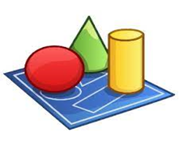Is an enterprise modeling tool built to work in Microsoft Windows, and runs under Eclipse through a plug-in. This program enables corporations to easily visualize, analyze and manipulate data for efficient enterprise information structural design.

This tool will be used in making the representation of the structure, relationships, activities, processes, information, resources, people, behavior, goals, and constraints of a business or enterprise.

Power Designer has integrated support for:

- Business Process Modeling supporting Business Process Modeling Notation  
 - Code generation for Java, C#, VB, .NET, EJB3, JSF, Win Form, and others.  
 - Data Warehouse Modeling  
 - Eclipse plug-in  
 - Object modeling (UML 2.0 diagrams)  
 - Report generation  
 - XML Modeling supporting XML Schema and DTD standards  
 - Visual Studio 2005 add-in

## StarUML

StarUML is an open-source project to develop fast, flexible, extensible, featureful, and freely-available UML/MDA platform running on Win32 platform. The goal of the StarUML project is to build a software modeling tool and also platform that is a compelling replacement of commercial UML tools.

StarUML is mostly written in Delphi. However, StarUML is multi-lingual project and not tied to specific programming language, so any programming languages can be used to develop StarUML. (For example, C/C++, Java, Visual Basic, Delphi, JScript, VBScript, C#, VB.NET ...)

## Canva

Canva is an Australian global multi-national graphic design platform that is used to create social media graphics and presentations. The app includes readymade templates for users to use. Creating an account and using Canva is free, although the majority of high quality elements will need to be paid for in order to download one's project. The app also offers paid subscriptions such as Canva Pro and Canva for Enterprise for additional functionality. In 2021, Canva launched a video editing tool. Users can also pay for physical products to be printed and shipped. Examples of products that can be made on Canva include yard signs, business cards, chore charts, album art, ebooks, infographics, menus and invitations. The company has announced it intends to compete with Google and Microsoft in the office software category, with website and whiteboard products. On December 7, 2022, Canva launched Magic Write, which is the platform’s AI-powered copywriting assistant. On March 22, 2023, Canva announced its new Assistant tool, which makes recommendations on graphics and styles that match the user's existing design.

# Conception

## Use case diagram

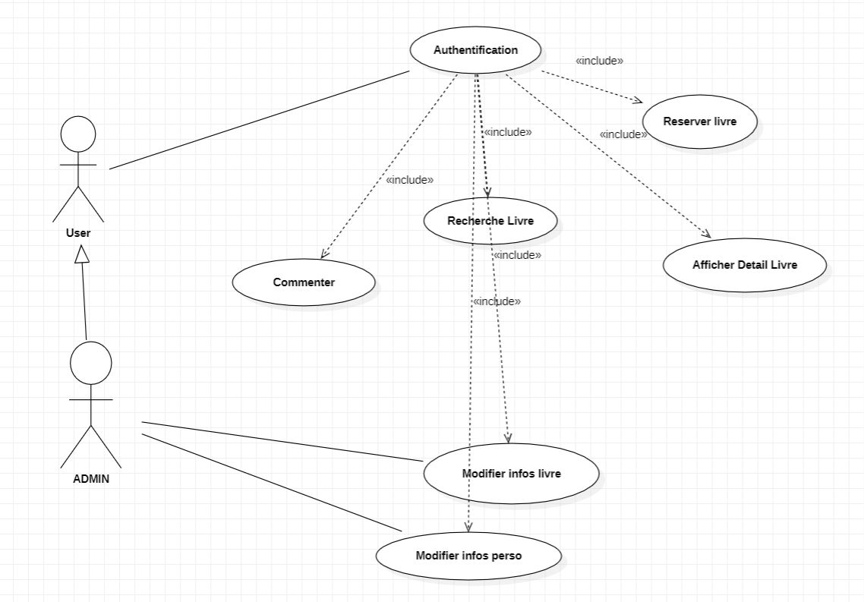

The Use Case Diagram represents the structure of the functionality needed by users of the system. It is used in the two stages of capturing functional and technical needs.

***Administration:***

+ Manage books and multimedia resources

+ Accept orders of new books

+ Check book status

+ Send notices

+ View usage statistics and reports

+ Add or remove users

***Students:***

+ View book details

+ Search for books

+ Reserve a book

+ View availability of books

+ Borrow a book

+ View borrowed books

+ Receive notifications

+ Rate and review books

+ Access e-books and multimedia resources

+ Save books to Wishlist or favorites

+ Collect points to get badges (Active Reader)

+ Lose points for overdue books

***Teacher:***

+ Add new course material

+ View course material

+ Manage course material

***External User:***

+ Access external resources

* In this use case diagram, there are four main actors: User, Student, Teacher, and Administration. The User actor represents anyone who uses the app or website. The Student actor represents students who use the library to borrow, reserve, and access books and resources. The Teacher actor represents teachers who use the library to manage and access course materials. The Administration actor represents the staff who manage the library resources and services.
* Each actor has their own set of use cases that represent the actions they can perform within the app or website. The Student actor can search for books, reserve them, rent them, receive notifications, and access e-books and multimedia resources. The Teacher actor can add and manage course materials and view them. The Administration actor can manage books and multimedia resources, accept orders of new books, check book status, send notices, view usage statistics and reports, and add or remove users.
* The External actor represents external services or resources that the app or website can integrate with to provide additional features and resources. This could include external libraries, online bookstores, or educational resources.

Figure 1: Use case diagram

## Class diagram

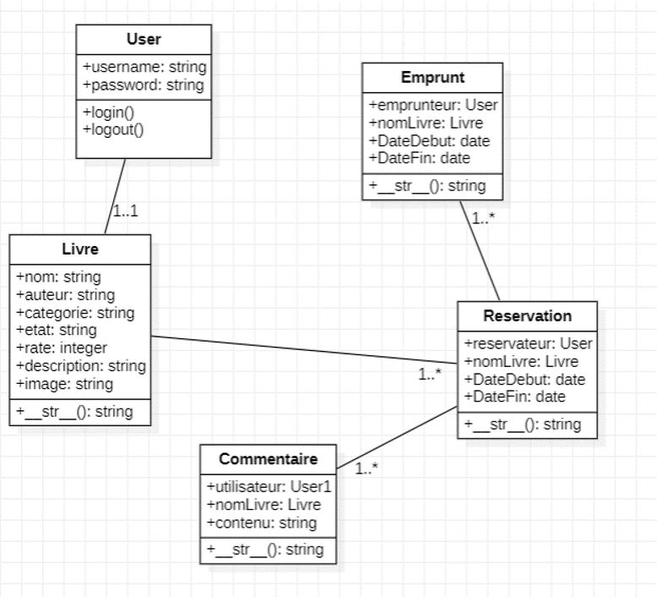

## Sequence diagram

1. login

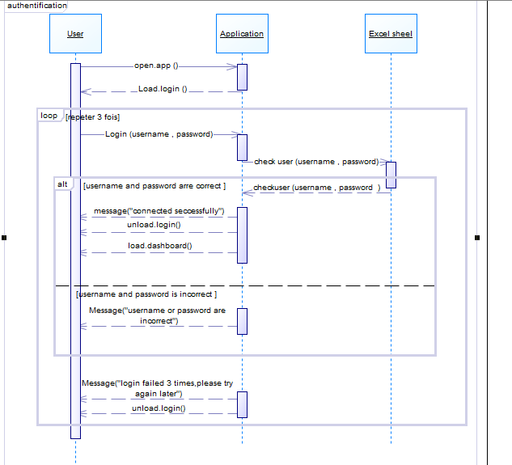

Figure 2: Authentication sequence diagram

1. add

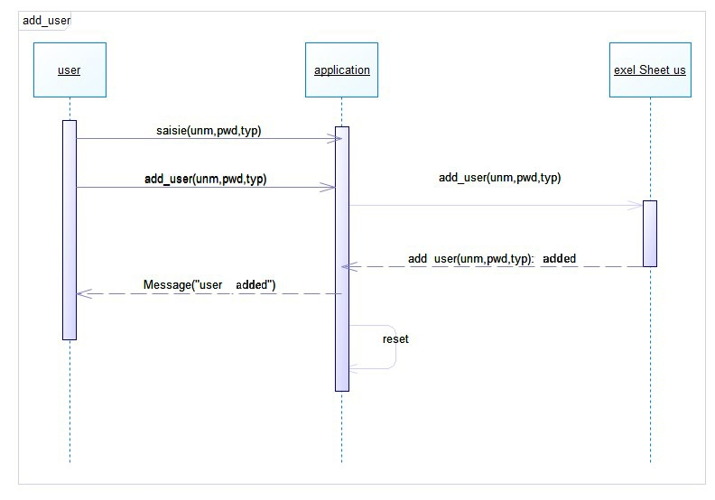

Figure 3: Add user sequence diagram

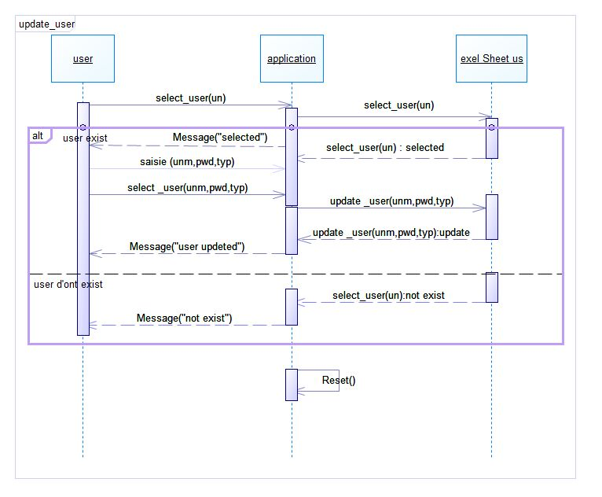

Figure 7: Update user sequence diagram

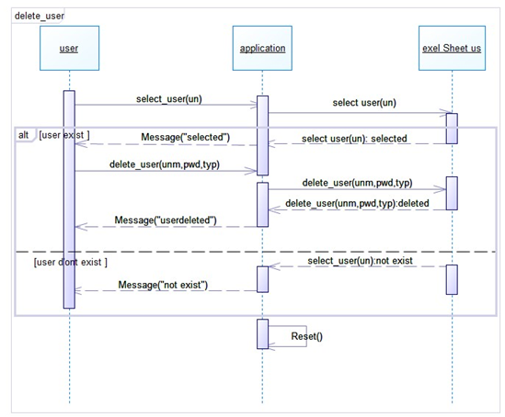

Figure 12: Delete user sequence diagram

1. logout

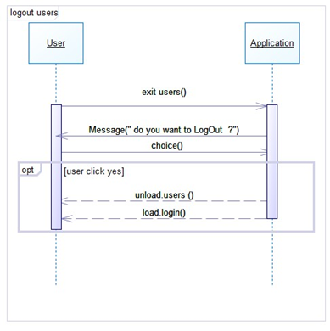

Figure 16: Logout users sequence diagram

1. menus

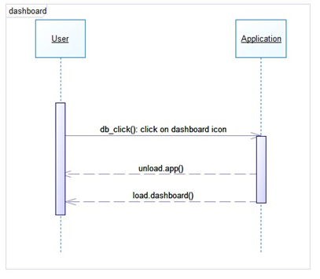

Figure 22: Dashboard sequence diagram

# Realization

This is the landing page where you can contact and learn more about us

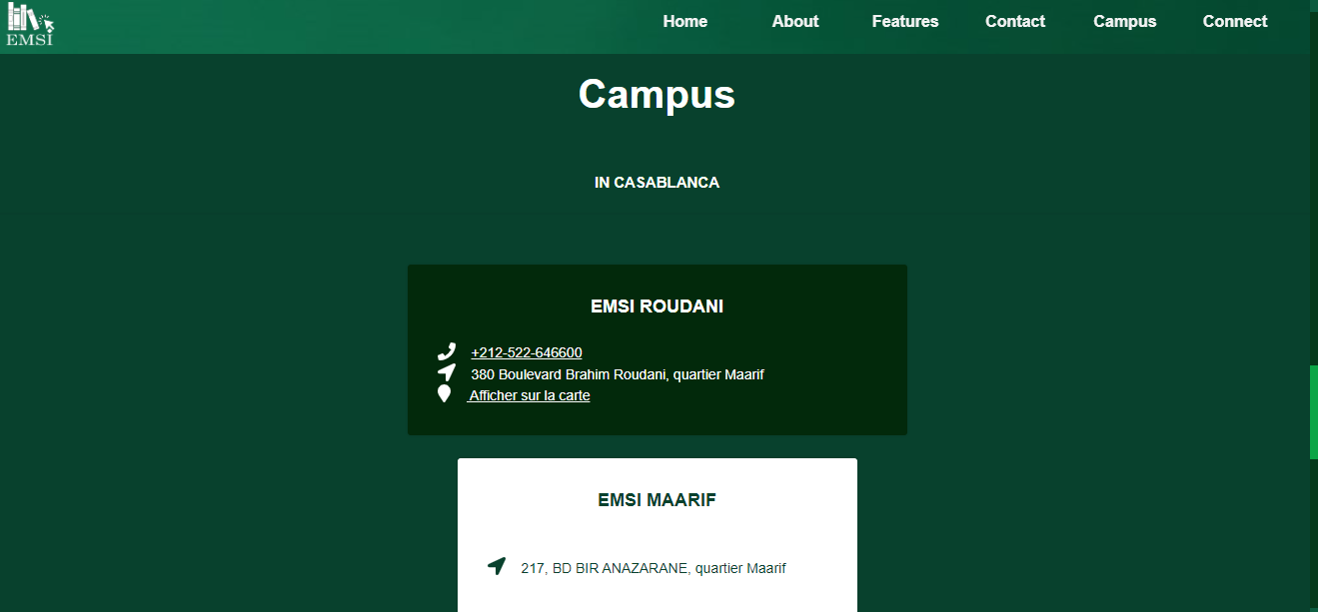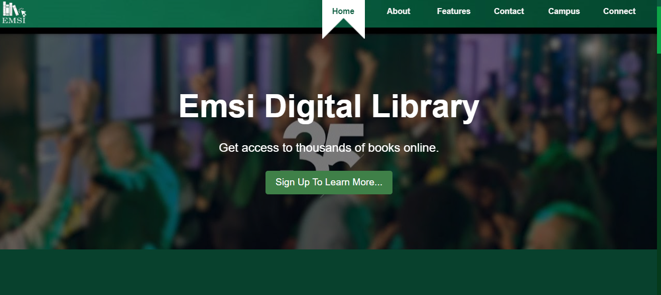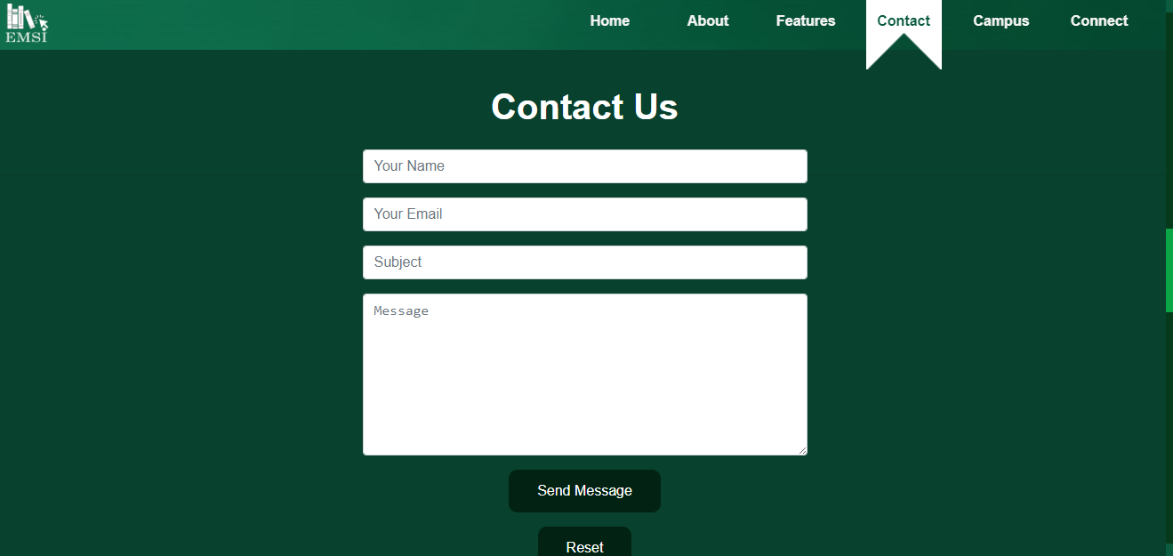

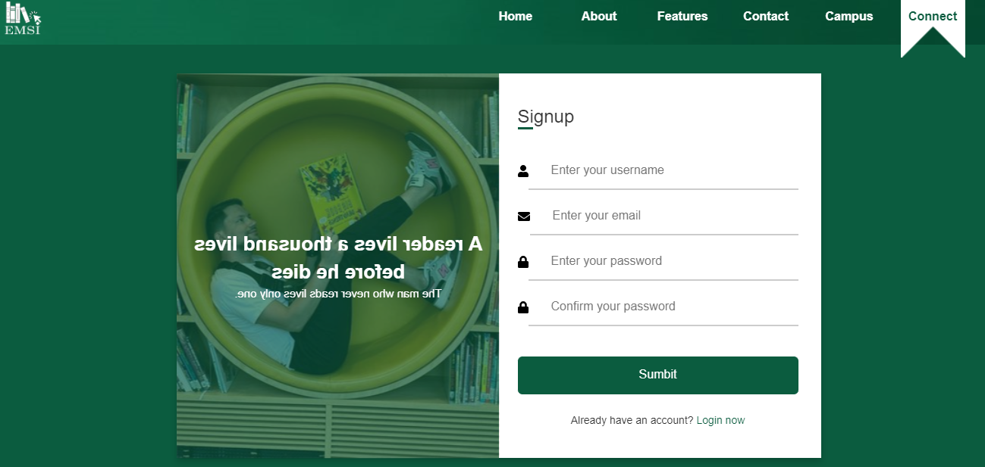

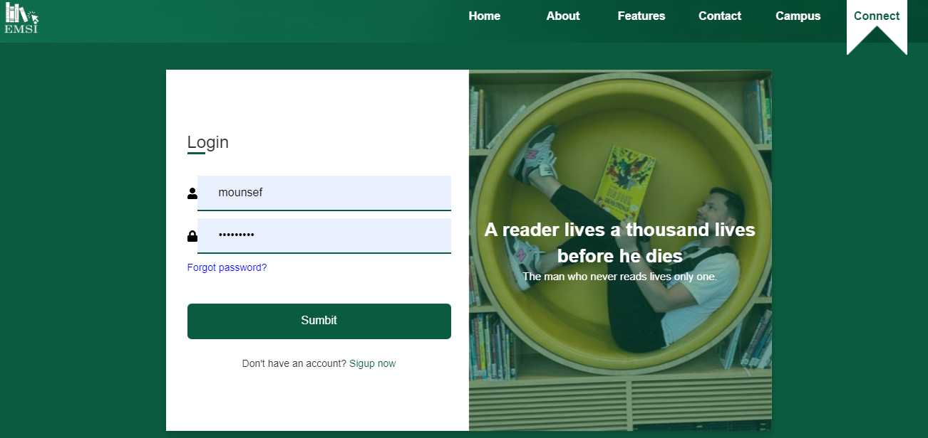

This interface allows you to login to the system, you only have three shots to get you login info right, those info are giving from one of the admins, you should enter your password and username to authenticate and then click on login button, you can also show you password that is already written as stars by clicking on the show password or the eye and to hide it again you just click on hide password or the eye again. If u wish to exit you can close the page.



This will be you destination after login, you can navigate thru the menu bare of the other interfaces or see profile or search or logout.

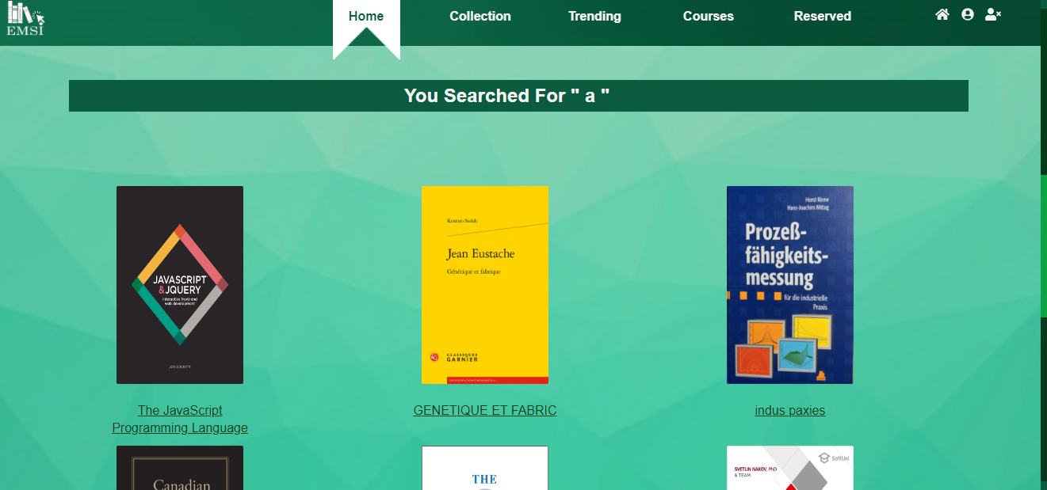

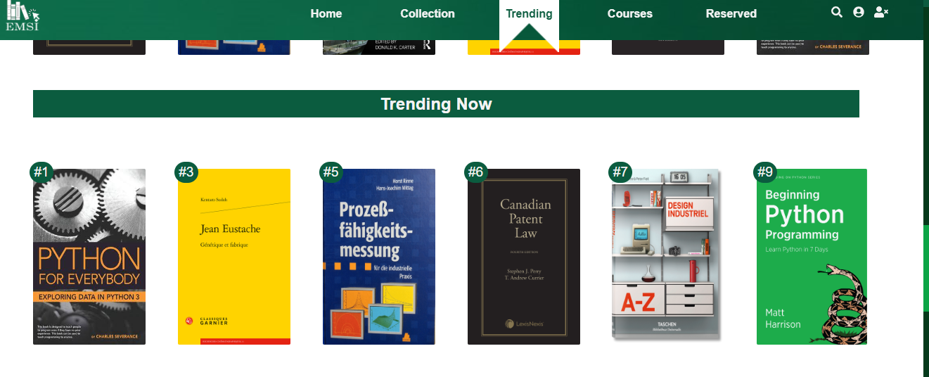

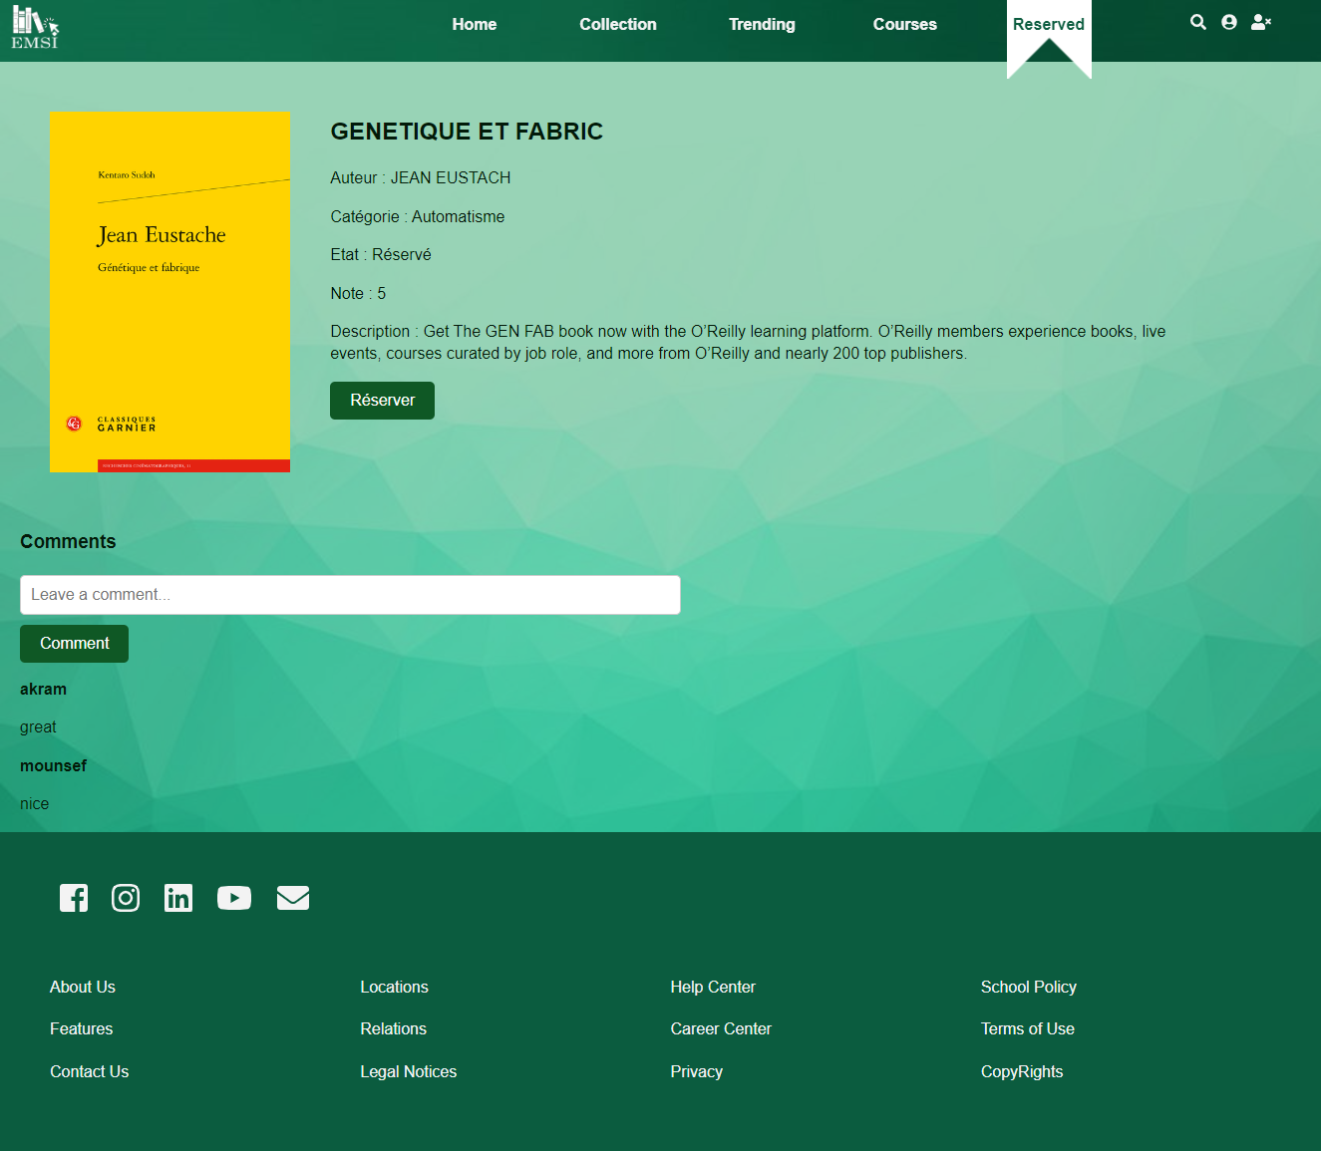

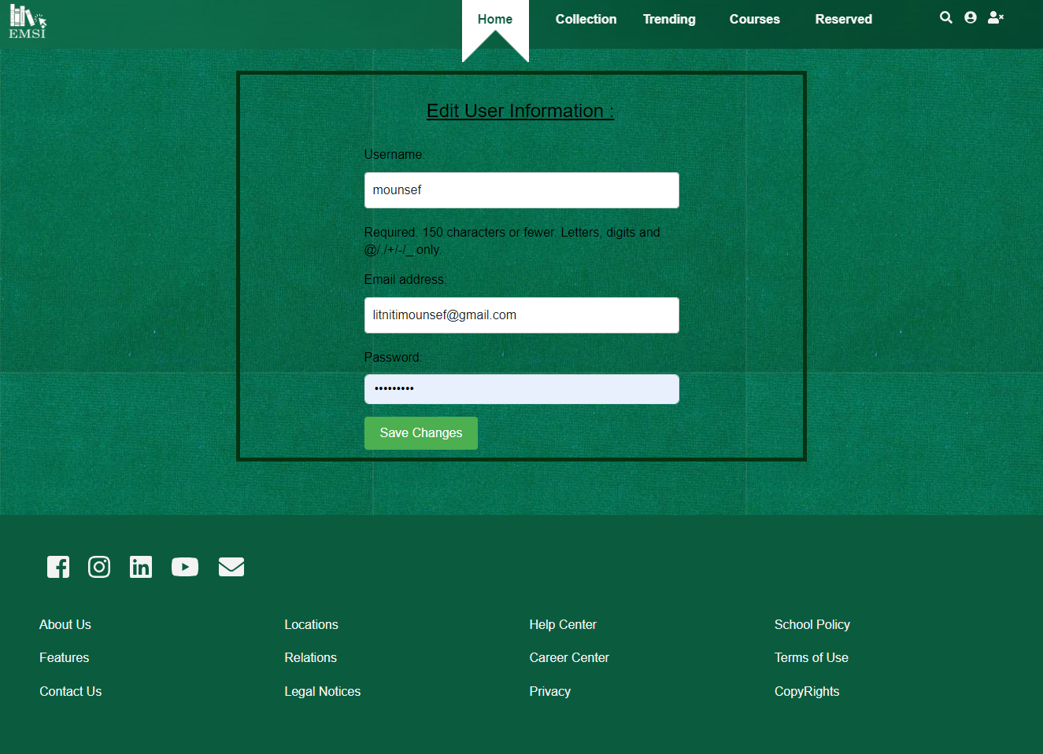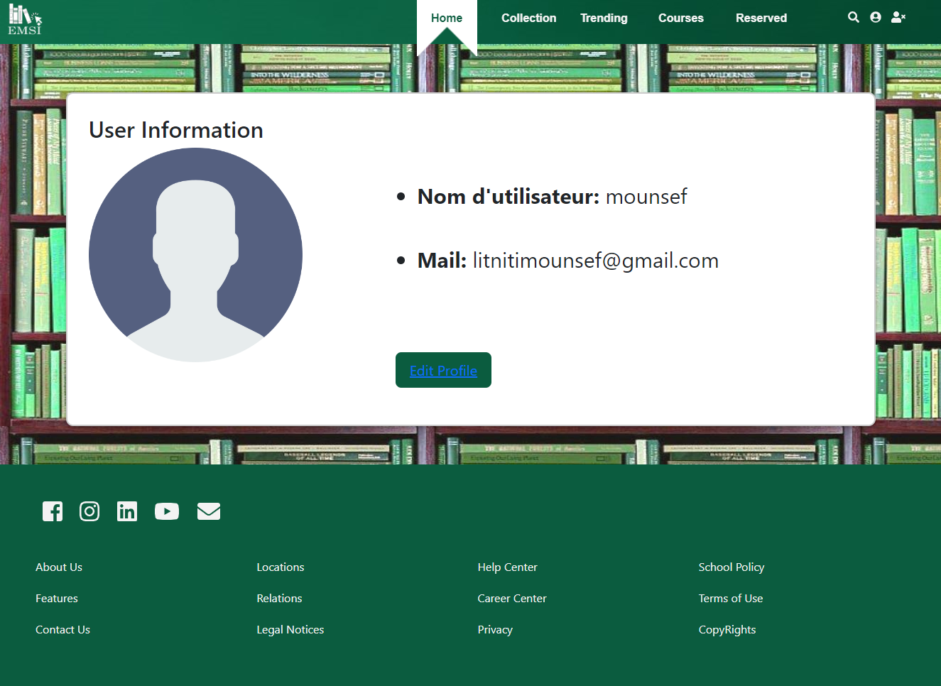

## Annex du code

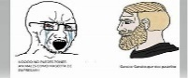

Very long code

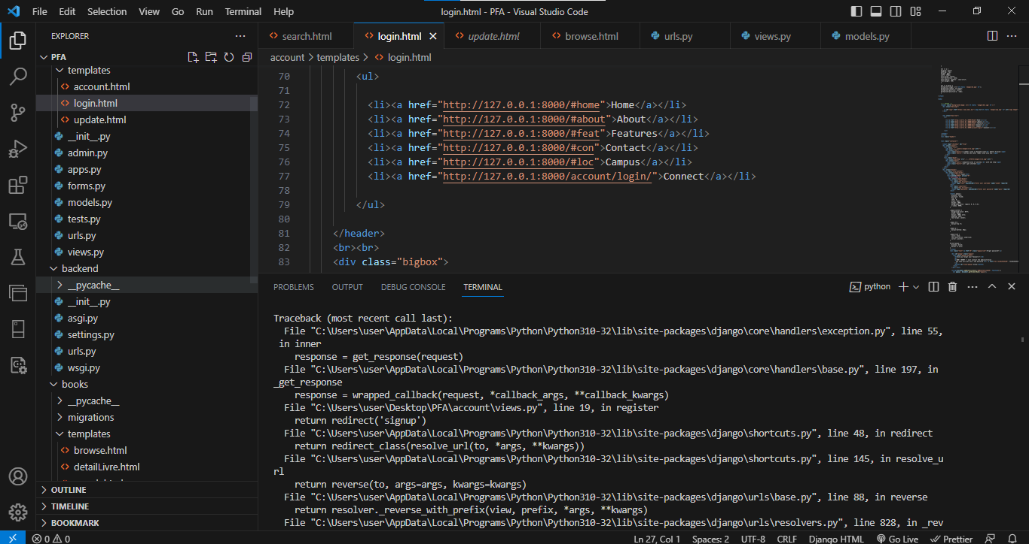

# Perspective Conclusion

In this project we did created an Library Webapp, that can manage books ,users and also monitoring and view all of them. We did achieve that by using our gained knowledge from this year django course in each step toward the realization of this solution.

We did achieve everything we hope in this project, nothing more, nothing less. we are proud of our work but if we had more time we could add more features that I mention before and also add more functionalities like PDFs E-Books.